

The College of New Jersey

2000 Pennington Road

Ewing, NJ 08628

P) 609.771.2466

F) 609.637.5122

E) sga@tcnj.edu

December 20, 2009

To: Dr. Cindy Curtis, TCNJ Faculty Senate President

Cc: Dr. R. Barbara Gitenstein, President

Dr. Jim Norfleet, Vice President of Student Affairs

Dr. Mort Winston, Chair of the Committee on Planning & Priorities

Dr. Nino Scarpati, TCNJ Staff Senate President

Ms. Magda Manetas, Assistant Vice President for Student Services & SGA Adviser

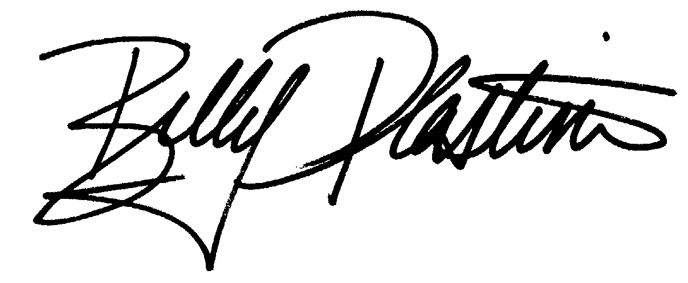

Fr: Billy Plastine, TCNJ SGA Executive President

Re: Big Issues from the TCNJ SGA for the 2010 Middle States Report

***Background and Data Collection***

Members of the TCNJ Student Government Association (SGA) Executive Board were asked to discuss perceived strengths, weaknesses, opportunities, and threats (SWOT analysis) for The College of New Jersey as an institution of higher education on October23, 2009. A SWOT analysis form was distributed to each Executive Board member beforehand, and each member of the Executive Board was asked to complete it and bring it to the October 23rd meeting. At the meeting, the group first paired up to discuss their initial responses. A second stage of discussion that involved the whole group helped narrow the focus of the SGA’s initial reaction to the central question: “What are the most pressing issues facing the student body and the institution as a whole that TCNJ should address within the next five years?” The Senators and Class Officers within the TCNJ SGA General Assembly were then asked to respond to a shorter version of the SWOT analysis completed by Executive Board members on November 4, 2009. This information helped confirm that the big issues identified by the Executive Board were as closely representative of the student body’s opinion as possible. Overall, a total of 71 responses were collected over this time period.

***Major Themes Reported from SGA Membership***

STRENGTHS

* The perception of value for money offered by TCNJ
* The college has been effectively marketing our value to differentiate us from peer institutions
* There is student representation in most of the important decisions made by the college
* There are many volunteer opportunities and classes that focus on civic engagement
* Smaller class sizes foster communication and research partnerships between students and faculty
* There is great depth and breadth amongst TCNJ student organizations, which allow students to continue to develop leadership skills in a co-curricular environment
* The research resources provided by the library are conducive to student’s learning and research needs[1]
* The Welcome Week program is highly effective in getting students acclimated to campus and eases the transition to independent life
* Technological support services and programs (most notably PAWS and SOCS) are effective

WEAKNESSES

* Quality of academic advising[2]
* Lack of national recognition; outside the tri-state area, TCNJ is generally unknown
* There is a need for more connection between the current student body and TCNJ alumni
* Constant struggle for space (large meeting space, on-campus housing, etc.)
* Prospective students and their families are not aware of the honors program
* Fewer and smaller scholarships offered to students (including the loss of OSRP)
* Lack of geographical diversity amongst undergraduates (overwhelming percentage of students are from NJ)

OPPORTUNITIES

* TCNJ could better use its proximity to Trenton (for lobbying efforts, community-building activities, etc.) and New York City, Philadelphia, and the “Route 1 Corridor” to increase the number of institutions that recruit from TCNJ, offer more civic engagement opportunities, sponsor more internship opportunities, etc.
* The institution could better market the Study Abroad Program at TCNJ to boost participation so that students have a feeling of having had the total college experience upon graduation and further student appreciation for global issues
* TCNJ could increase on-campus activity and build an even stronger campus community via the implementation of a Town Center that best meets the needs and interests of the student body; this will strengthen the bonds that exist within our campus community and could help mitigate prospective students’ concern that TCNJ is a “suitcase school”
* Schools and departments should consider establishing peer mentorship programs for underclassmen. In these programs, underclassmen could be paired up with an upperclassmen and share ideas, anticipated career paths, experiences, and best practices; students believe this is an “untapped resource” and that the establishment of these programs will enhance the overall advisement experience for students
* The institution can further increase involvement with corporations that sponsor internships at the college and/or recruit for full time positions (e.g., corporate sponsorship)

THREATS

* A small endowment, difficulty of attaining student participation in the Student Giving Campaign, and little direct contact with TCNJ alumni threaten current students’ participation in TCNJ alumni activities in the future
* The difficulty of overcoming the reputation of TCNJ as a “suitcase school”, a reputation that still exists despite significant efforts from various constituent groups to overcome the stereotype
* Lack of state government support (budget cuts, little scholarship opportunities) continues to force the college to cut from budget areas that are important to students (e.g., physical enhancement center, hours of operation for the library, renovation of the student center, etc.)
* The perceived increase in adjunct professors might reduce the opportunity students currently have to forge beneficial relationships with full-time faculty[3]

***Conclusion***

The above summary indicates the big issues identified by the Student Government Association; all items listed in the previous section were common responses found within the SWOT analyses of SGA members. If you have any questions or would like additional clarification or information, please do not hesitate to contact me via email at sga@tcnj.edu. On behalf of the SGA, I’d like to thank you for including us in this very important process.

1. The Library section of the TCNJ website and the up-to-date technology in the Library wee identified as specific strengths frequently
2. Academic advising was overwhelmingly the most significant concern; it was listed as a “weakness” in nearly 75% of the SWOT analyses completed by SGA members.
3. Some adjuncts are held in very high regard, but on the whole, an increase in their use leads to a decrease in student interaction with full time faculty. This often leads to reductions in the likelihood of students participating in research, lack of a connection between students and their major department and/or academic school, and little involvement in department and/or school sponsored co-curricular organizations, lectures, events, etc.